

**Al Imam Mohammad Ibn Saud Islamic University College of Computer and Information Sciences**

**Information Systems Department**

Name: Ali Alkhurayif

Project: E-Business Strategy, Architecture and Design



Help

Glossary

For ideas download the example business plan in pd format from [www.bdc.ca](http://www.bdc.ca)  
Help is available by clicking on a

?Help

**TABLE OF CONTENTS**

Your business plan is divided into the following sections:

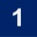 Business Overview

Description of the Business 2

Major demographic, economic, social and cultural Factors 2

Major Players 2

Trends in the Industry 2

Government Regulations  2

The Market

Market Segment  3

Products & Services  3

Pricing and Distribution  3

Market trends  3

Implications or risk factors  3

The Competition

Competitors and type of competition  3

Competitors' Strengths and Weaknesses 3

Competitive advantage  4

 Sales & **Marketing** Plan

Customers  5

Suppliers 5

Advertising & promotion 5

Pricing & distribution 5

Customer service policy 6

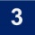 Operating Plan

Business location & requirements / advantages / lease details 7

Equipment / technology / R&D / environmental aspects 7

 Human Resources Plan

Key employees 9

Policies & procedures 9

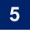 Action Plan

Action plan & timetable 10

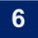 Executive Summary

[A brief description of the project, the financing required,   
and additional information that help explain the business plan 11](#Objectives)

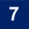 APPENDIX: Financial Plan

The company’s financial performance both historical and projected (available in the kit [Excel spreadsheet](http://www.bdc.ca/EN/articles-tools/entrepreneur-toolkit/templates-business-guides/Pages/business-plan-template.aspx)). Includes sales cost of goods sold expenses income statement balance sheet cash flow budget financial requirements performance indicators and personal status. 14

HOW TO PRINT THESE INSTRUCTIONS

[FINANCIAL PLAN (EXCEL SPREADSHEET)](http://www.bdc.ca/EN/articles-tools/entrepreneur-toolkit/templates-business-guides/Pages/business-plan-template.aspx)

Help

Glossary

In this section, you give a brief description of your company and where it stand in the marketplace.

|  |  |  |  |
| --- | --- | --- | --- |
| Company-to-be Legal name: | Coffee Online Store | | |
| Company-to-be Trading name: | Coffee For You | | |
| Company-to-be Business address: | Ath Thumamah Road, Riyadh 13323 | | |
| Company-to-be Phone: |  | Fax: |  |
| Company-to-be E-mail: |  | | |

# 

# Description of the Business

?

In saudi arabia , there is big relaationship between people and coffe, and as we know there are many type of coffes. In, our project goal to create an e-commerce website to let the coffee lovers browse the coffee types and pushase the coffe with choosen quantity.

# Major demographic, economic, social and cultural Factors

?

Our website will offer a variety of choices to the customers ( Turkish, arabica , espersso).

# Major Players

?

The main target of our project is sell coffee online. We can remmand a coffee machine to buy from other website.

# Nature of the Industry

?

There are no many online coffee store is Saudi Arabia.

Our goal is to promote the online coffe e-commerce.

# Trends in the Industry

?

Coffee is an increasingly important part of today's lifestyle. For most saudian people, coffee is the fuel that gets them going in the morning

# Government Regulation

?

Since we will buy food it will be required to get a general business license from the Saudi Food & Drug Authority (SFDA).

THE MARKET

# Market Segment

?

The process of dividing the total market into different groups of target customers who have

different needs, features, behaviors is market segmentation.The website will provides all type of coffees to customers, and will be focused on (students , employers) which are strong customer segments.

# Products & Services

?

The website will carry a variety of quality products that will enable us to provide full service delivery to coffee and coffee machine. Our underlying philosophy in selecting products is to choose lines that will bring consistent quality, competitive prices, and product satisfaction to our customers and also a full service delivery.

# Implications or Risk Factors

?

Starting a coffe website can have tremendous benefits but you have to face some challenges :

* Provide the lowest prices to attract customers.
* Starting a business requires capital.
* Provide a variety of choices of coffee (Starbucks, etc.)

# Planned Response

?

Our marketing approach is let saudi citizens discover new tastes of coffees and types.

Our marketing approach aims at high quality services, customer satisfaction, to motivate them on coffee online shopping for what the labor market lacks.

THE COMPETITION

# Competitors and type of Competition

?

Currently there are no many competition and the website that offer coffee online shopping is belonging to recognized companies to sell their products.

# Competitors' Strengths and Weaknesses

?

As we already mentionned there are no real online store to sell coffee. Our strength is to offer in our website strong brand images, which makes us strong in the labor market and creates the spirit of our competition. There are initial weaknesses such as people prefer to buy coffee at real shop instead online.

# Competitive Advantage

?

Our website is distinguished by offering many brand because when for example we offer starbucks brand, it will be a great advantage to our website. Also our webiste is a innovative idea and targeting every class of society. We can also offer a free coffee for taste .

Help

Glossary

# If you are a start-up and do not yet have clients or suppliers you should still contact potential clients and suppliers and include letters of intent and market research information to help show your sales potential.

# Customers

|  |  |  |  |  |
| --- | --- | --- | --- | --- |
|  | **NAME \ ADDRESS** | **TERMS** | **PRODUCT / SERVICE** | |
| **1** | All categories of society | NA | Coffee | |
|  | | | |

# Suppliers

|  |  |  |  |
| --- | --- | --- | --- |
|  | **NAME \ ADDRESS** | **TERMS** | **PRODUCT / SERVICE** |
| **1** | Arabic coffee | N/A | With and without “heel” |
| **2** | Turkish coffee | N/A | With and without “heel” |
| **3** | Espresso coffe | N/A | Classic and arabica |

# Advertising & Promotion

?

The site will be promoted and announced via social media and TV channels. We will follow the amazing offers policy, to win customers.

# Pricing & Distribution

?

N/A

# Customer Service Policy

?

Our Customer Service Policy begins by addressing the needs , expectations of the customer.

Help

Glossary

In this In this section, describe the physical aspect of your business operations: your location, current and future capacity, lease details, your equipment and technological requirements, and any environmental or other regulations that apply.

# Location

?

Website.

# Size and Capacity

?

N/A

# Advantages or Disadvantages

?

Can access the website from anywhere and anytime.

# Lease or Ownership Details

?

N/A

# Equipment, Furniture & Fixtures

?

Using wix to build the website and hosting out surce.

# Future Expenditures / Technology Requirements

?

Sell more type of coffee and coffee machine.

# Research and Development

?

We focused our research on coffees that appeal to most consumers.

# Environmental Compliance

?

N/A

# Additional Information

?

The coffee and coffee machen is stored in a large warehous, They are equipped with means that maintain the quality of the coffee so as not to spoil

Help

Glossary

This section details your human resources plan: key staff, policies & procedures. If your business is expanding, indicate what future resources will be needed.

# Key Employees

?

|  |  |  |  |  |  |  |
| --- | --- | --- | --- | --- | --- | --- |
|  | **NAME OR TITLE (Nº OF POSITIONS)** | | **KEY  RESPONSIBILITIES** | | **QUALIFICATIONS** | |
| **1** | | CEO of warehous | | Manage the warehous | | bussiness mangment | | |
| **2** | | Technical staff | | Manage the website | | Information system or  Information technology. | | |
| **3** | | Customer services | | Solve customer problems | | Clear communication skills,  Knowledge of the product | | |
| **4** | | Delivery staff | | Collect the customer's request and deliver it to him | | Driving License | | |
| ADDITIONAL INFORMATION  N/A | | | | | | | |

POLICIES AND PROCEDURES

# Hours of Operations

?

8 hours, from 10A.M. to 6P.M.

# Number of Employees

?

10 full-time and 2 principals, 2 part-time.

# Vacation Program

?

30 days each year and the 2 holidays(eid).

# Performance Assessment

?

Last day of each month.

# Training & Development

?

Training programs are offered to improve the efficiency of work every 6 months, as well as plans to develop the working environment..

# Remuneration and Benefits

?

The wages are given every month, and there are bonuses given to staff who work hard.

Help

Glossary

This section details the future action the business plans to take, usually over the next 2 to 3 years.

# Action Plan

?

|  |  |  |  |
| --- | --- | --- | --- |
|  | **ACTION** | **BY WHEN** | |
| **1** | Study the need of project. | Apr 2018 | |
| **2** | Study the market. | May 2018 | |
| **3** | All important permits were taken from government agencies (Ministry of Commerce, Food and Drug Administration) | Jul 2018 | |
| **4** | Purchase a warehouse | Sep 2018 | |
| **5** | Employment of workers )technical staff,customer services,delivery staff) | Oct 2018 | |
| **6** | Devolope wibsite | Nov 2018 | |
| ADDITIONAL INFORMATION  N/A | | |

Help

Glossary

In this section, you provide a summary of the reasons you are seeking financing, together with a summary of your business operations.

# Objectives / Description of the Project

?

The idea of the project is to sell a coffee and coffee machine to customers, Our goal is to be the best coffee sellers in the market.

# Business History / Nature of Operations K

?

The project will be implemented at the beginning of 2018 and will last several years, and the nature of the project will make purchasing coffee easier for customers.

# Products and Services

?

Our products are coffee and coffee machine, and we have (After sales service).

# Project Financing

?

Create an website 4000 RS

Purchase a warehouse 500000 RS

Marketing the project 20000 RS

Purchase equipment 10000 RS

# Management / Advisors

?

# Director 1

Abdulelah almutairi, President (40% ownership)

23 years old. Over 3 years’ experience with the mangment

Main responsibilities: marketing, business planning.

# Director 2

Salman alrusayni, Deputy Director (30% ownership)

24 years old. 5years’ experience with building websites

Main responsibilities: sales invoicing, financial operations.

# Director 3

Saleh Alqasmol, Corporate Secretary (30% ownership)

24 years old. 5 years experience in programming

Main responsibilities: meeting scheduling, purchasing.

# Risk Assessment & Contingency Plan

?

We plan to finance our expansion in bahrain although alliances with local partners will be sought if necessary. We have already begun talks with potential partners in the bahrain, but if sales targets are not met, our option is to sell back the proposed equipment to the supplier so that we can meet the loss that will be incurred. The building addition adds value to our property

# Financial Institution

?

N/A.

# Supporting Documents

?

N/A.

Help

Glossary

**Note:** The financial plan is found in a separate spreadsheet, available as a [download here](http://www.bdc.ca/en/business_tools/business_plan/default.htm).   
Complete this file and include it in this appendix.

This is the end of section 1-6.   
Please print this document by clicking on the button below.

PRINT

Help

#### A B C D E F G I L M N O P R S T V W

#### [ ACCOUNTS PAYABLE]

Back to top

Amounts owed by a business to its suppliers, usually as a result of credit purchases for inventory or services, other expenses (i.e. utilities), or taxes.

#### [ ACCOUNTS RECEIVABLE]

Amounts owed to a business by its customers who purchased goods or services on credit.

#### [ ACCRUALS]

Amounts due to employees but not yet disbursed, sales tax collected but not yet sent on, etc.

#### [ ADMINISTRATIVE EXPENSES]

Operating costs incurred in the normal course of running a business, such as telephone, management and office salaries, professional fees, property taxes, etc.

#### [ AGE OF ACCOUNTS RECEIVABLE]

A ratio that shows how fast a business is collecting from its customers. The higher the number, the longer it takes the business to receive payment, translating into a possible lack of working capital.

#### [ ASSET]

Anything owned by a person or a business that has commercial or exchange value. Assets may be tangible or intangible and may include accounts and notes receivable, cash, inventory, equipment, real estate, goodwill, etc.

#### [ ASSET TURNOVER]

Financial ratio that measures the business' use of assets to generate income, more specifically the level of capital investment relative to its sales volume. The higher the turnover, the more efficiently the business is managing its assets.

A  **B**  C  D E F G I L M N O P R S T V W

#### [ BALANCE SHEET]

Back to top

Financial statement listing all assets, liabilities and equity of a business at a certain point in time. It provides a quick "snapshot" of a business.

#### [ BOOK VALUE]

Value of an asset as shown on the balance sheet. The book value takes into account depreciation and is often different from its market value.

#### [ BREAK-EVEN POINT]

The point in time at which a new business’ revenues (dollar volume of sales) equals its fixed and variable expenses.

#### [ BUDGET]

An estimate of future income and expenses over an accounting period (quarterly, yearly, etc.) used as a financial control for business.

#### [ BUSINESS FINANCING PLAN ]

An outline of the business goals, the purposes of its loans, and the benefits to the business resulting from the loans. It can also include summaries of historical, market and other data.

A  B  **C**  D E F G I L M N O P R S T V W

#### [ CAPITAL ]

Back to top

The owner's equity in the business. It can take the form of the proprietor's or partners' capital, or, if incorporated, that of common stock, preferred shares and retained earnings.

#### [ CASH FLOW BUDGET ]

A spreadsheet of monthly inflows (e.g., earnings) and outflows (e.g., expenses) of cash in the business during an accounting period, usually 1 year. It helps a business plan its financial requirements.

#### [ CLOSING INVENTORY ]

Value of the total inventory or the number of units that a business has on hand at the end of the accounting period.

#### [ COGS ]

Abbreviated form of Cost of Goods Sold, also called Cost of Sales.

#### [ CONTRIBUTED SURPLUS ]

Any capital contributed to a business other than through the issue of shares. It includes share redemption, donation from a shareholder, certain dividend transactions.

#### [ CORPORATION ]

Legal entity incorporated under federal or provincial legislation. This entity is distinct from parties or individuals that own it. Shareholders are not liable for debts or obligations of the corporation.

#### [ COST OF GOODS SOLD ]

Abbreviated as COGS, also called cost of sales. Direct cost of producing or providing the business' goods or services. It includes direct labour costs and production overhead plus opening inventory plus purchases less closing inventory.

#### [ CURRENT ASSETS ]

Cash and other assets that, in the normal course of operations, may be converted into cash, or consumed into the production of income within one year from the date of the Balance Sheet. They include cash, accounts receivable, allowance for doubtful accounts, inventory and prepaid expenses.

#### [ CURRENT LIABILITIES ]

Outstanding debts of the business that are payable within one year of the date of the Balance Sheet. They include a credit line, accounts payable, , accruals (ex. sales tax collected), income tax and current portion of the long term debt.

#### [ CURRENT RATIO ]

Financial ratio that measures the business' ability to meet its current obligations on time and to have funds available for its current operations.

A B C  **D**  E F G I L M N O P R S T V W

#### [ DEPRECIATION ]

Back to top

Method of spreading the cost of a fixed asset over several accounting periods so that expenses are matched to the revenues they help produce. It is an allowance for the wearing out of equipment.

#### [ DISBURSEMENTS ]

Funds paid out of a business in settlement of obligations.

#### [ DRAWINGS ]

Withdrawals of assets (usually cash) from a business by a sole proprietor or a partner.

A B C D  **E**  F G I L M N O P R S T V W

#### [ EQUIPMENT ]

Back to top

All machinery and equipment used by the business to earn revenue. It has a limited lifespan and thus is subject to depreciation.

A B C D E  **F**  G I L M N O P R S T V W

#### [ FINANCIAL STATEMENTS ]

Back to top

Formal reports, prepared from accounting records, describing the financial position and performance of the business. They comprise the Balance Sheet, the Income Statement, the Statement of Changes in Financial Position. See also these definitions.

#### [ FIXED ASSETS ]

Also called capital assets. Property or equipment, not intended to be sold, owned by a business for use in its operations and expected to have a useful life of several fiscal periods. Included in this are land, buildings, vehicles, furniture and equipment.

#### [ FIXED COSTS ]

Amounts that do not vary with changes in the volume of sales or production (i.e. rent, depreciation, interest payments).

#### [ FORECAST ]

Estimate or prediction of future sales, expenditures, profits, etc.

A B C D E F  **G**  I L M N O P R S T V W

#### [ GROSS PROFIT ]

Back to top

Net Sales less Cost of Goods Sold. It represents the profit made by the business before deducting selling, administrative and financial expenses. It helps to evaluate sales performance, buying policies, mark-ups, and inventory controls.

A  B C D E F G  **I**  L M N O P R S T V W

#### [ INCOME STATEMENT ]

Back to top

Financial statement showing revenues, expenses and net income of a business over an accounting period.

#### [ INCORPORATION ]

Legal process of bringing a company into existence by filing appropriate documentation with federal or provincial legislation.

#### [ INTANGIBLE ASSETS ]

Assets that cannot be touched, weighed or measured. They cannot be used for payments of debts and include goodwill (probability that a regular customer will remain so), patent, trademark, incorporations costs. They may produce income and can be sold, that is why they are listed under assets.

#### [ INTEREST COVERAGE RATIO ]

Financial ratio defined as Income before interest and taxes divided by Interest expense. It reflects the number of times business income cover interest expenses and represents a safety margin for the business.

#### [ INVENTORY ]

Dollar value (cost or market, whichever is lower) of all stock of physical items that a business uses in its production process or has for sale.

#### [ INVENTORY TURNOVER ]

Financial ratio that measures the number of times inventory has been sold in a given year. If it is low, it means that products are not selling well.

A  B C D E F G I  **L**  M N O P R S T V W

#### [ LABOUR EXPENSES ]

Back to top

Total direct cost to the business for its employees during an accounting period. Includes actual wages paid and cost of all fringe benefits, unless listed separately.

#### [ LEASE ]

Legal contract covering the use of property drawn up between an owner (lessor) and a tenant (lessee) for a stated amount of money (rent) and for a specified length of time.

#### [ LEASEHOLD IMPROVEMENTS ]

Renovations and other improvements done to the leased property at the expense of the lessee.

#### [ LIABILITIES ]

Amounts owed by the business to its creditors, not necessarily to be paid immediately. An obligation to remit money or services at a future date, ex. accounts payable, loans.

#### [ LINE OF CREDIT ]

Agreement between a lender and a borrower under which the latter can borrow continuously up to a fixed maximum amount.

#### [ LONG-TERM LIABILITIES ]

Outstanding term loans less the current portion (see definition of Current Liabilities) that are not due within the next 12 months.

A  B C D E F G  I  L  **M**  N O P R S T V W

#### [ MARKET ]

Back to top

A group of consumers that can be described in a specific way (e.g., men aged 25 to 35 with an annual income of over $40,000 and living in the Toronto area.)

#### [ MARKET SEGMENT ]

Part of a *market* (e.g., men aged 25 to 35 with an annual income of over $40,000 who live in the Toronto area and are interested in the arts)

A B C D E F G I L M  **N**  O P R S T V W

#### [ NET PROFIT ]

Back to top

Excess of all revenues over all expenses during the same accounting period.

#### [ NET PROFIT MARGIN ]

Net profit divided by sales; expressed as a percentage.

#### [ NICHE ]

Part of a *market segment* (e.g., men aged 25 to 35 with an annual income of over $40,000 who live in the Toronto area and are interested in performance arts)

A  B C D E F G I L M N  **O**  P R S T V W

#### [ OPENING INVENTORY ]

Back to top

Value of total inventory or number of units a business has on hand at the opening of the accounting period.

#### [ OPERATING FORECAST ]

Anticipated earnings of a business determined by estimating sales and subtracting expected expenses.

#### [ OPERATING INCOME (OR PROFIT)

Excess of revenue of a business over its expenses, excluding income derived from sources other than its regular activities, i.e. extraordinary income and expenses, income taxes, dividends, bonuses, withdrawals by owners.

#### [ OVERHEAD ]

Costs not directly attributable to the production of a good, ex. salary of factory manager, property taxes.

A  B C D E F G I L M N O  **P**  R S T V W

#### [ PARTNERSHIP ]

Back to top

Form of business ownership in which two or more individuals (or companies) provide the equity capital for a business enterprise. Partners share in the profits as well as the losses of the business.

#### [ PREPAID EXPENSES ]

Expenses paid in advance during an accounting period (ex. a two-year insurance premium), part of which will be "used up" in the upcoming accounting period. The unused portion of the expense is considered a current asset and recorded as such on the Balance Sheet.

#### [ PROFIT ]

Total revenue less total expenses for an accounting period calculated in accordance with generally accepted accounting principles.

A  B C D E F G I L M N O P  **R**  S T V W

#### [ RATIO ANALYSIS ]

Back to top

Analysis that compares financial ratios of a business from one year to another to determine the change in performance over time; it also compares financial ratios of a business to that of other similar businesses or to that of its industry to determine its performance in relation to others.

#### [ RETAINED EARNINGS ]

Profits not spent or distributed among owners of a business but reinvested in it.

#### [ RETURN ON ASSETS ]

Financial ratio that indicates how efficiently the business has used its available resources to generate income.

#### [ RETURN ON INVESTMENT ]

Financial ratio that measures the profitability of the business for its shareholders.

#### [ REVENUE ]

Gross proceeds received by a business from the sale of goods or services during an accounting period. It also includes gains from the sale or exchange of assets, interest and dividends earned on investments and other increases in owner's equity.

A  B C D E F G I L  M  N  O P R  **S**  T V W

#### [ SALES ]

Back to top

Total value of goods sold or revenue from services rendered. Returns and discounts must be shown as a reduction from total sales.

#### [ SELLING EXPENSES ]

Operating costs directly related to the selling of a product or service (selling salaries, commission, advertising, etc).

#### [ SHAREHOLDERS EQUITY ]

Net assets (i.e., minus liabilities) that belong to owners of the business.

#### [ SOLE PROPRIETORSHIP ]

Form of business owned and operated by one individual who is responsible for the debts and obligations of the business.

#### [ STATEMENT OF CHANGES IN FINANCIAL POSITION ]

Financial statement showing the fluctuation of capital of a business over an accounting period.

A  B C D E F G I L M N O P R S  **T**  V W

#### [ TERM LOAN ]

Back to top

Loan having a fixed term of repayment greater the one year, and a monthly or seasonal principal reduction schedule.

#### [ TOTAL DEBT-TO-EQUITY RATIO ]

Financial ratio that measures the solvency for the business: if this ratio is high, the business is at higher risk of not meeting its obligations should a drop in sales occur.

A  B C D E F G I L M N O P R S T  **V**  W

#### [ VARIABLE COSTS ]

Back to top

Expenses that vary directly with changes in the volume of sales or production, e.g. raw material costs and sales commissions.

A  B C D E F G I L M N O P R S T V  **W**

#### [ WORKING CAPITAL]

Back to top

Financial ratio that measures the amount of cash a business has to develop itself as opposed to the capital it has invested in fixed assets. A high ratio means the business can convert some assets into cash or obtain cash readily to meet its current obligations and represents a safety cushion for creditors.

Home Page:

As showing in the page we add promo code for black Friday

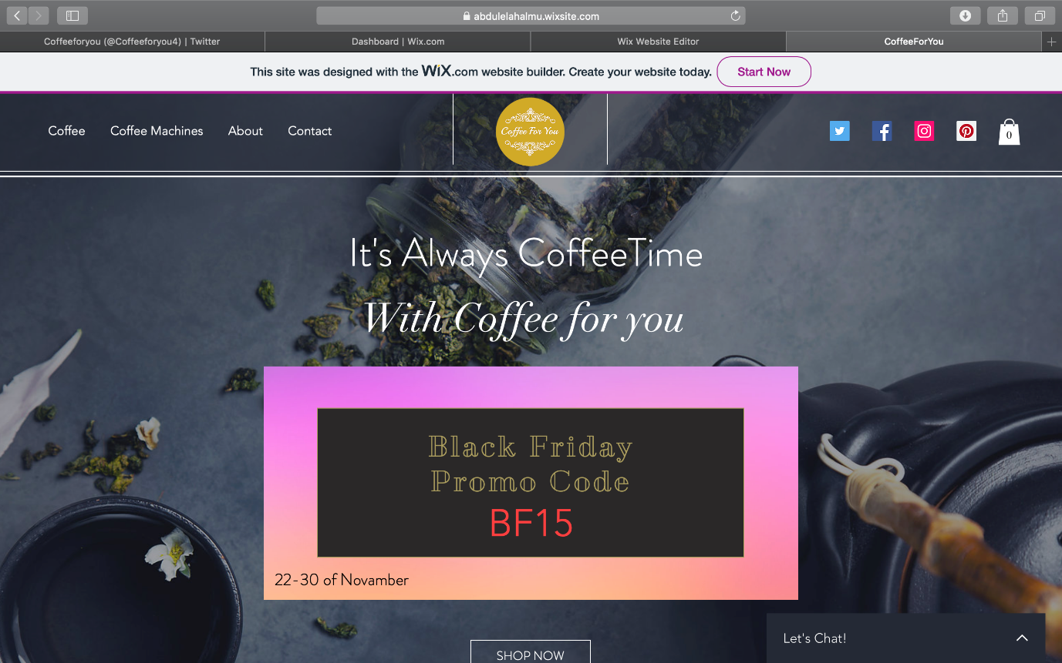

if you hovering on this ad you will see message.

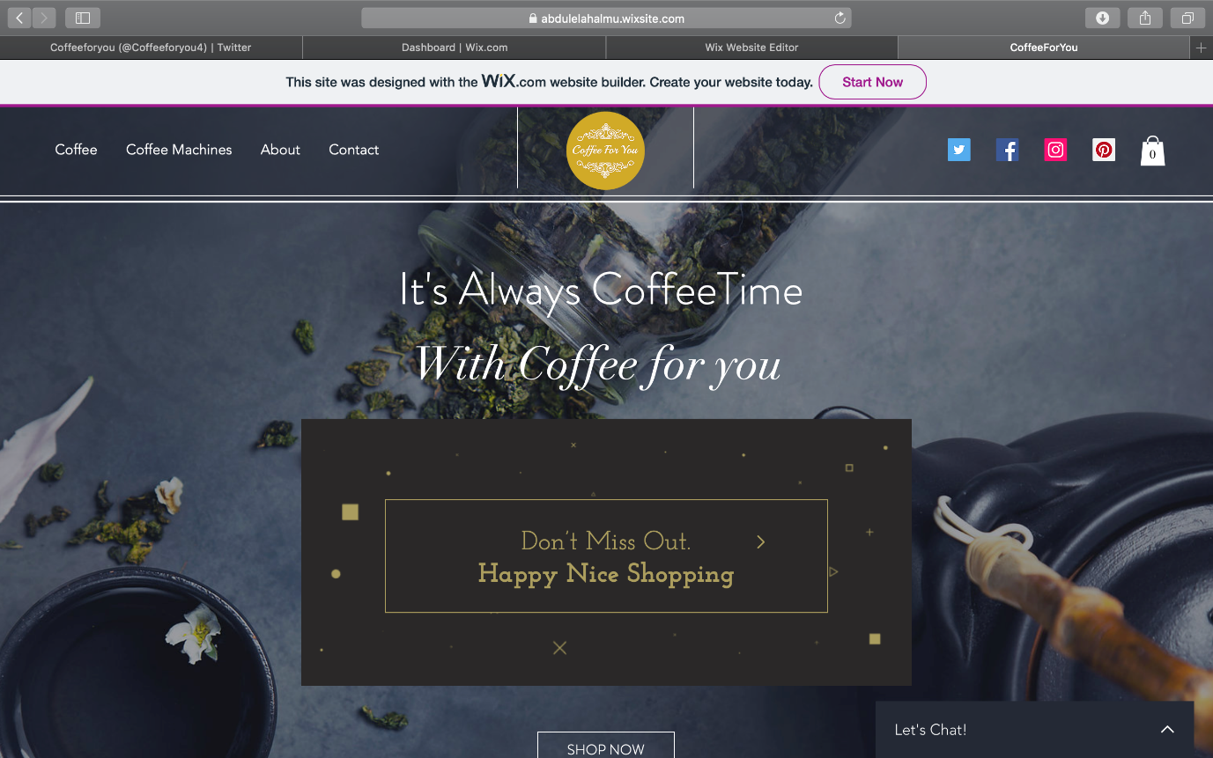

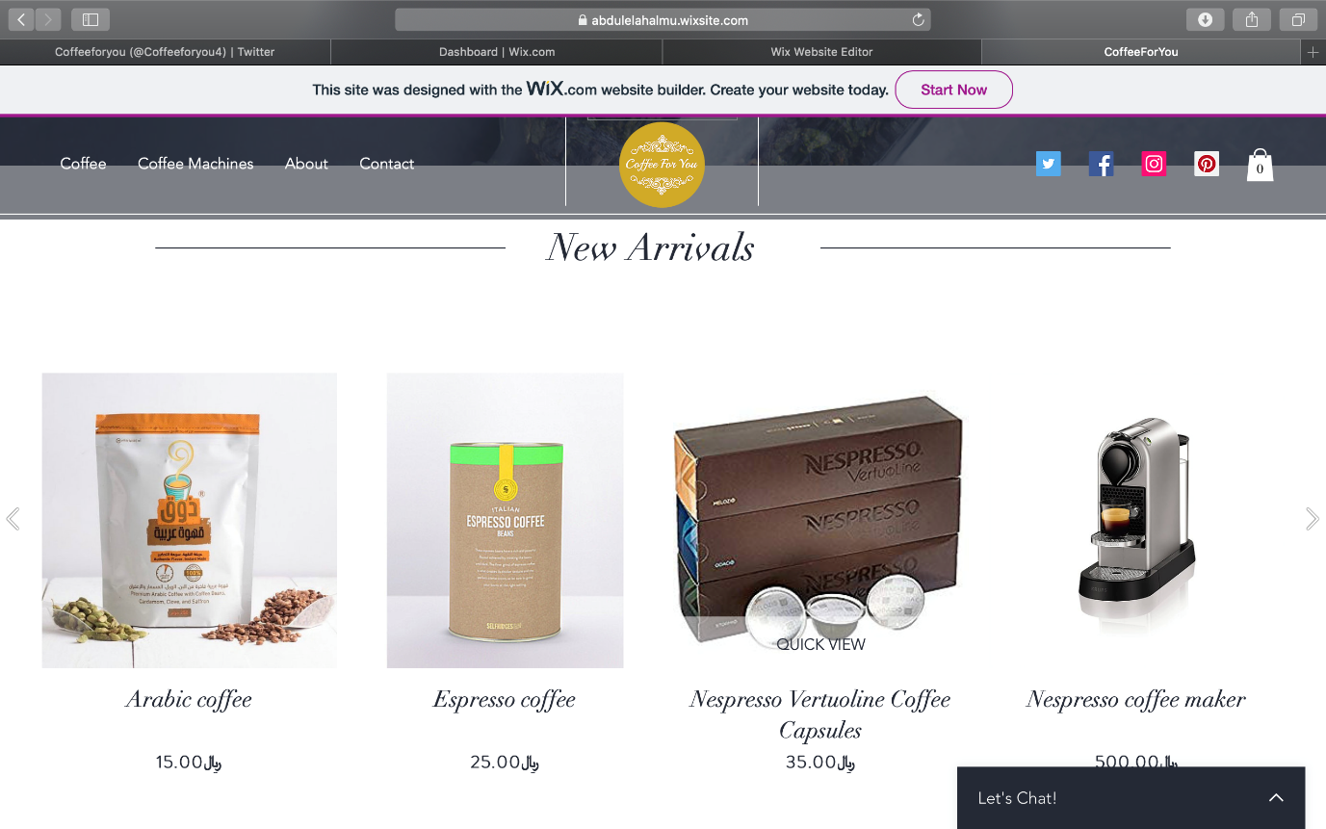

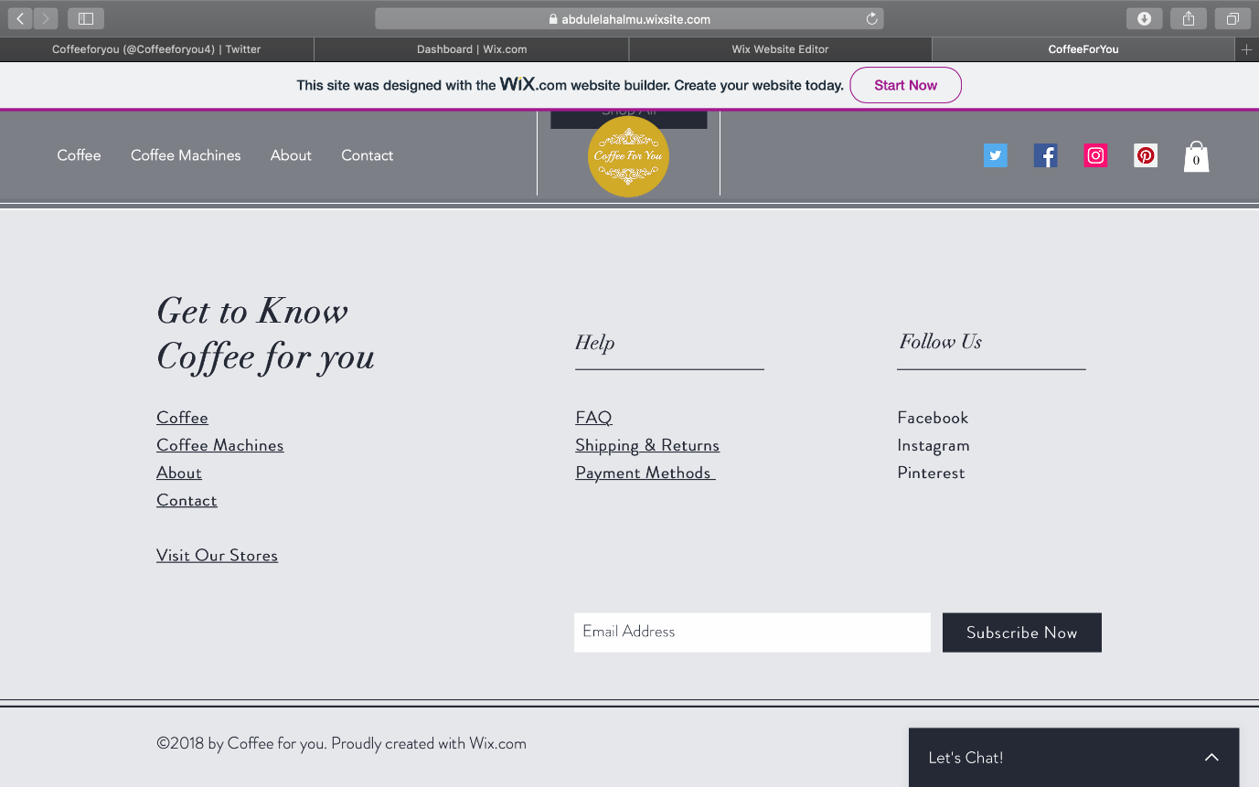

and her you can contact with us live,

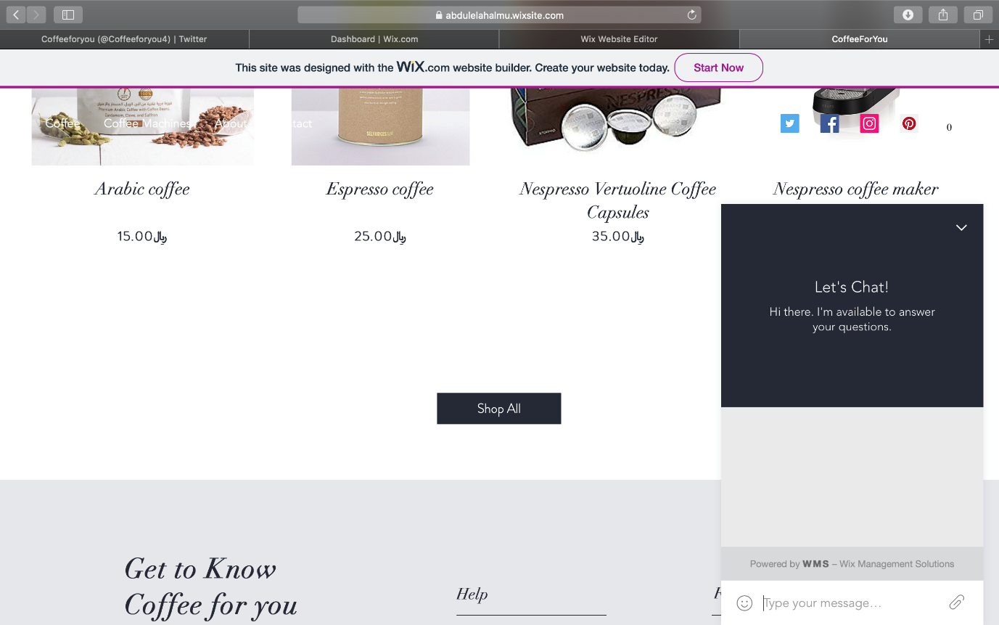

Coffee Page

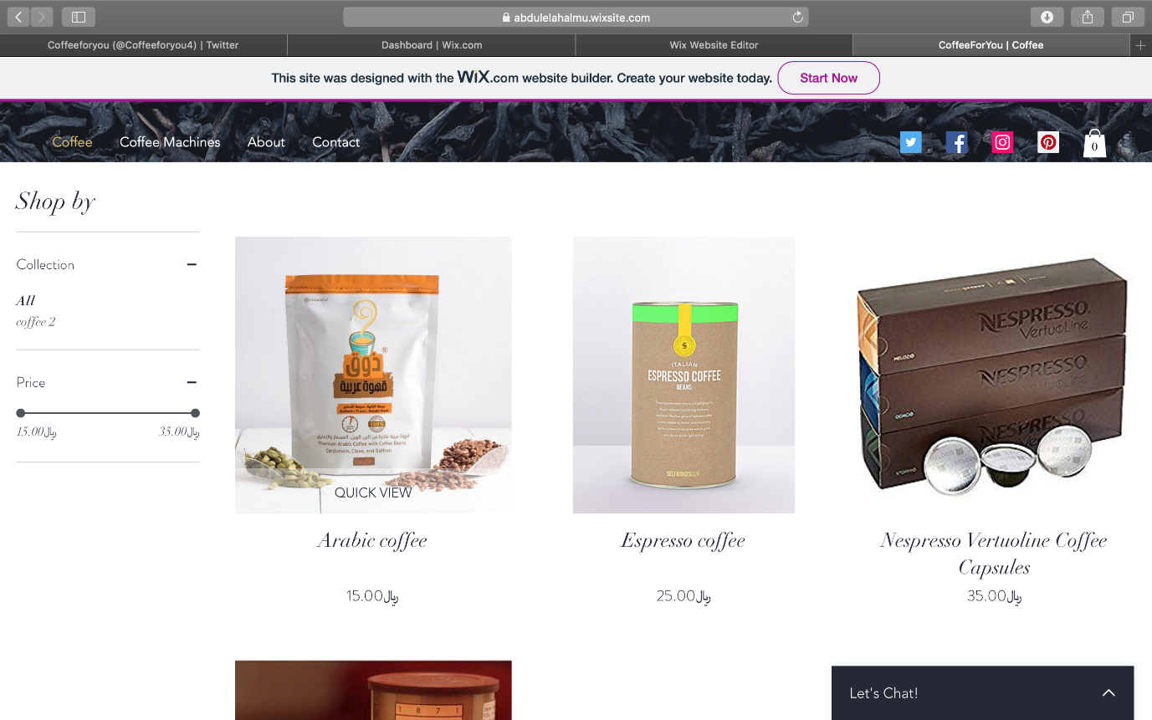

Select Quantity page:

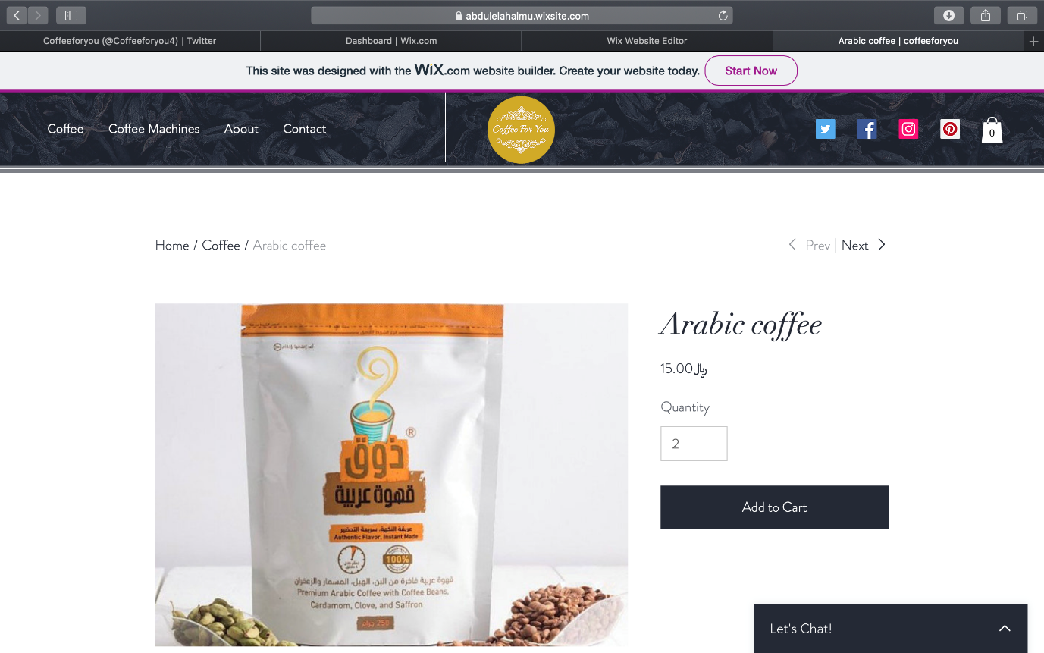

Coffee Machines page

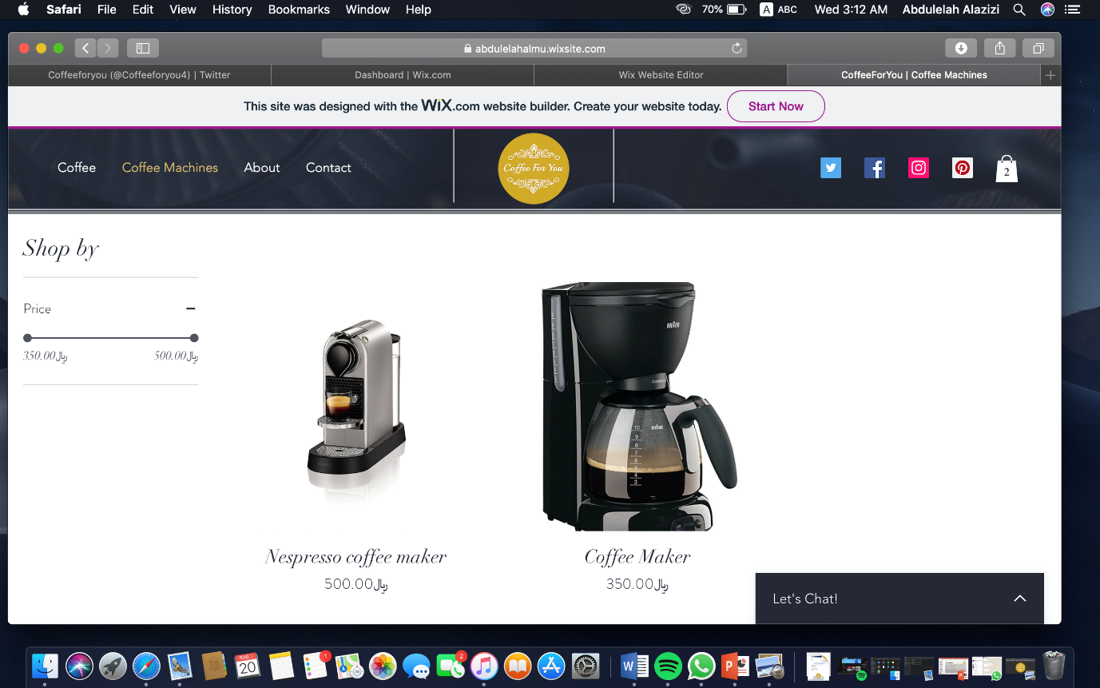

Another Select Quantity page for coffee machines:

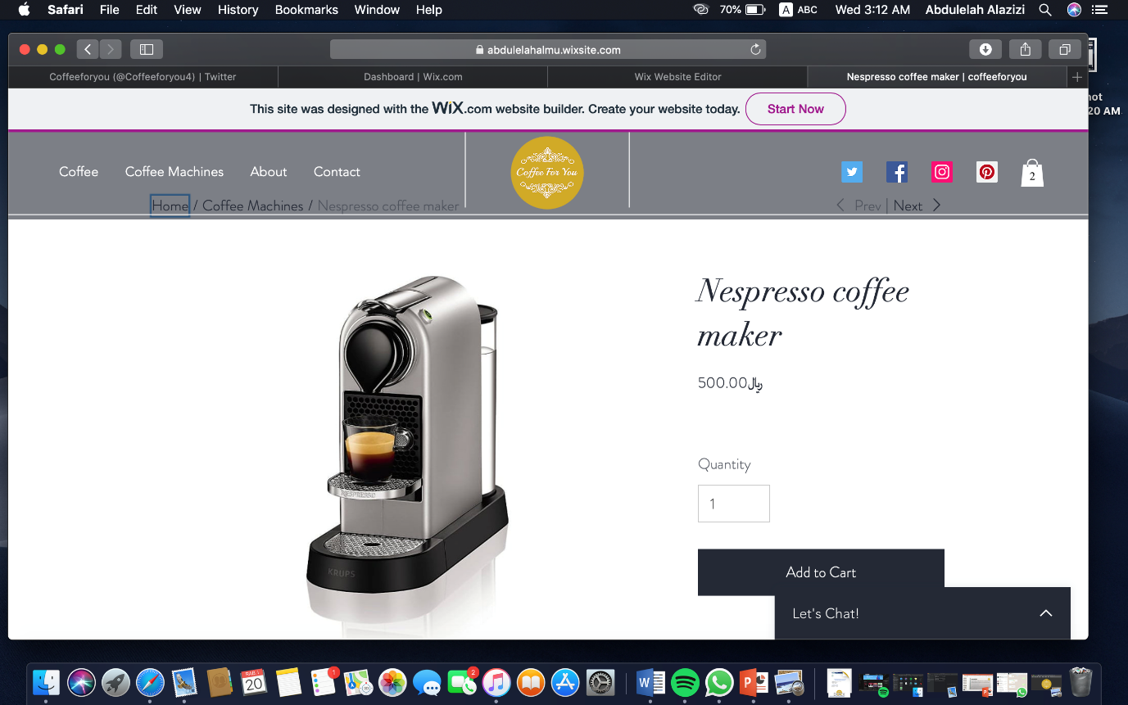

About us page:

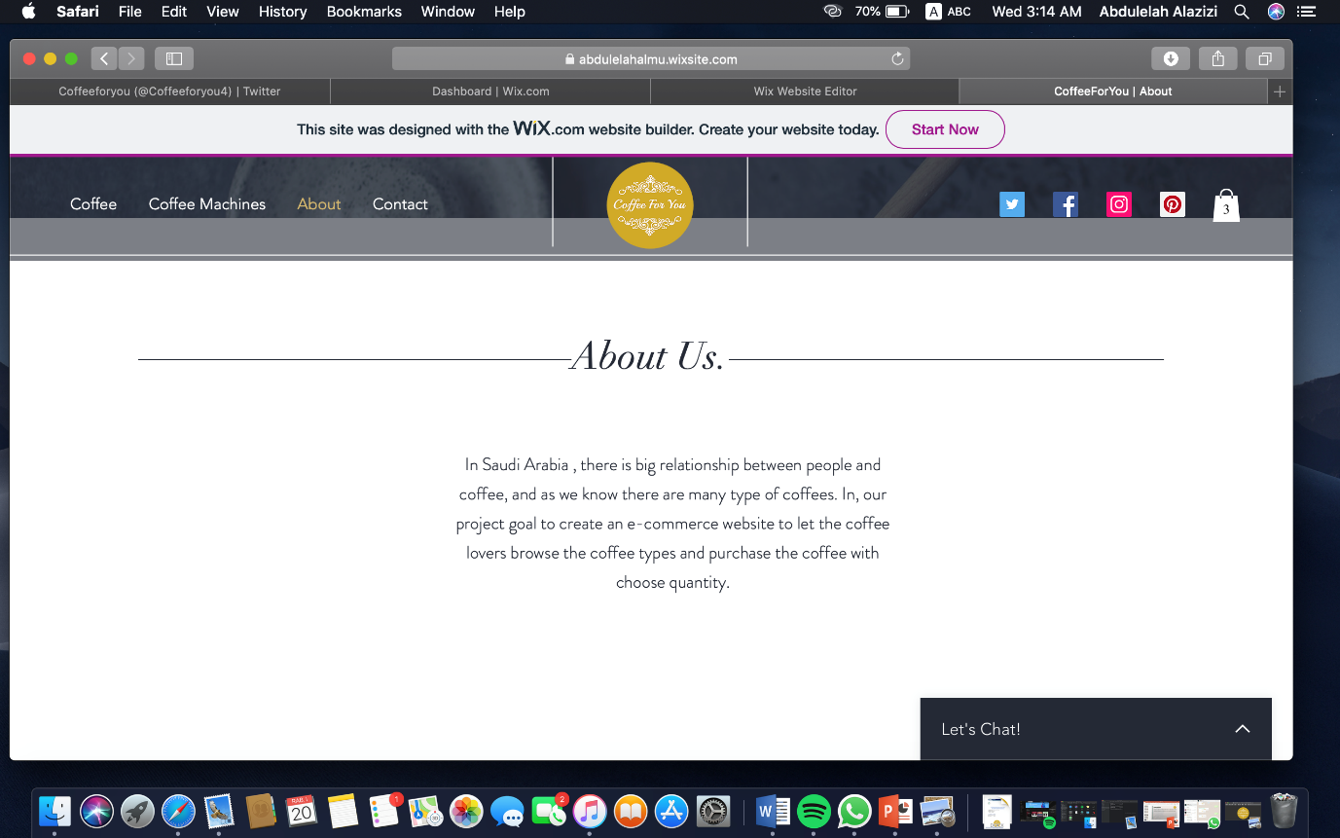

Contact us page :

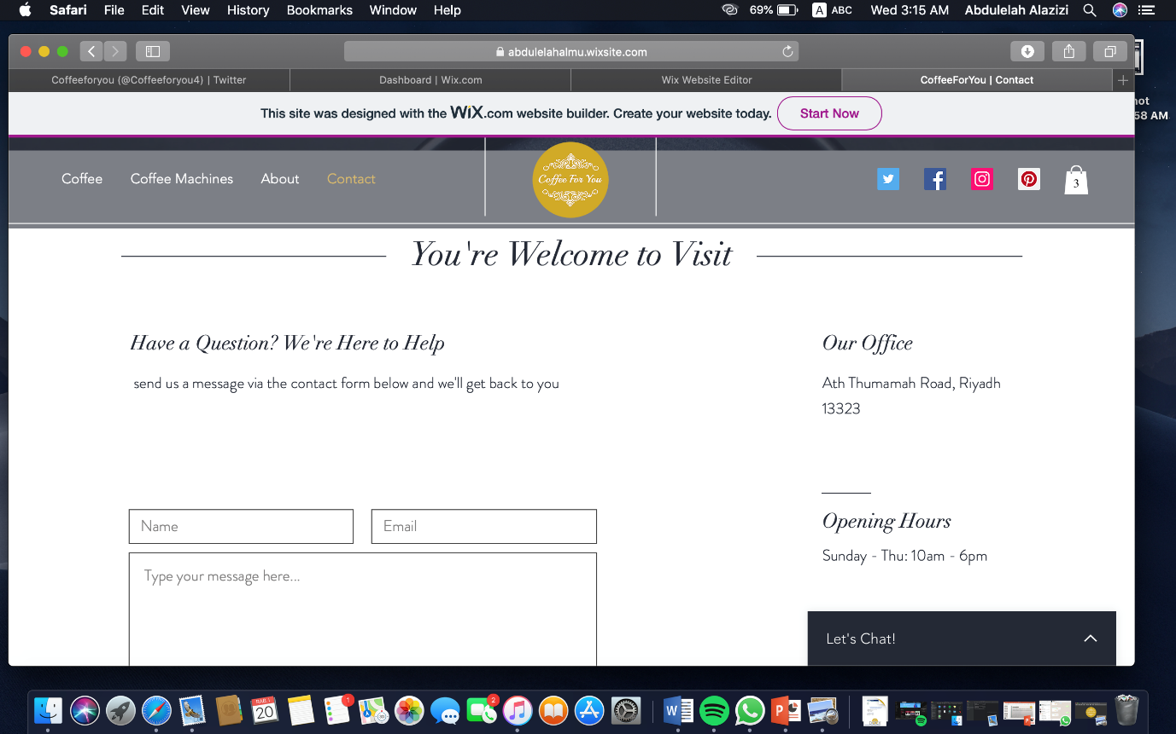

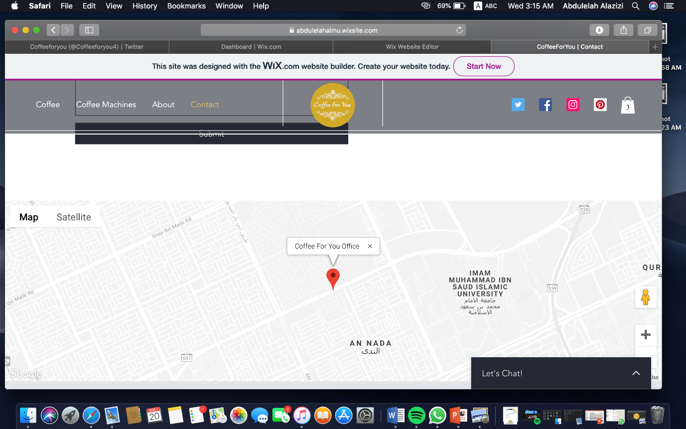

FAQ page:

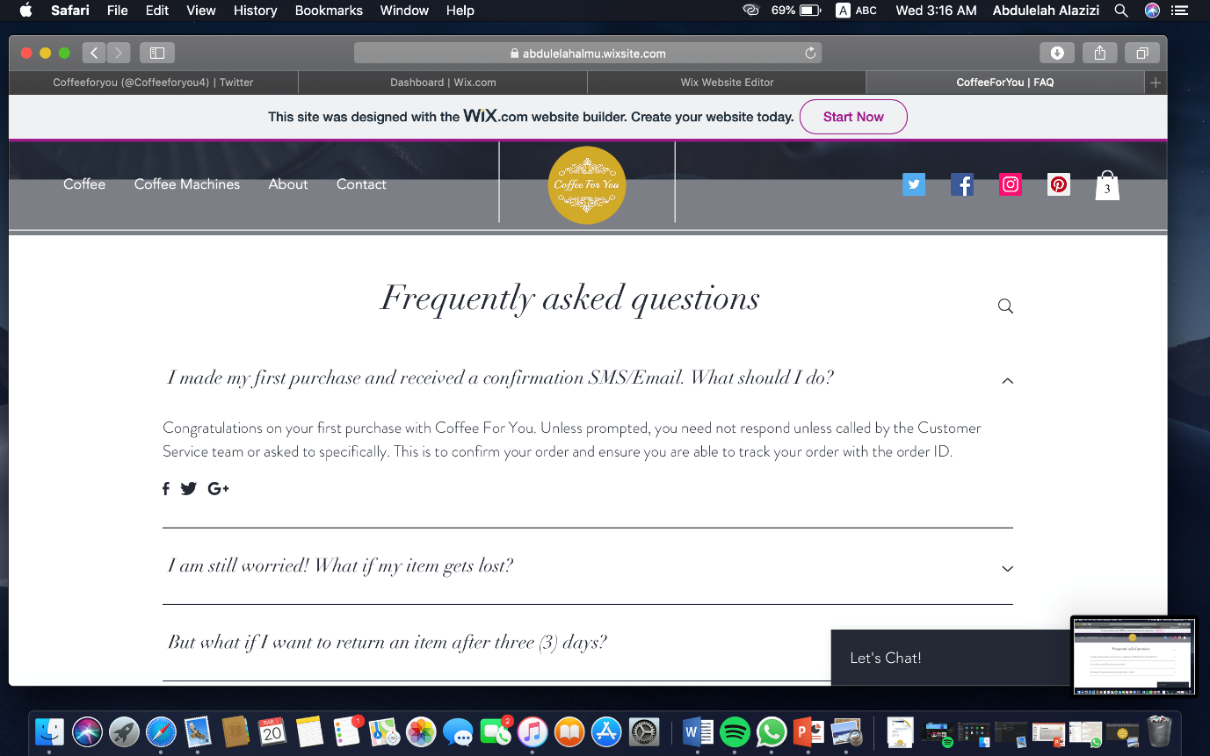

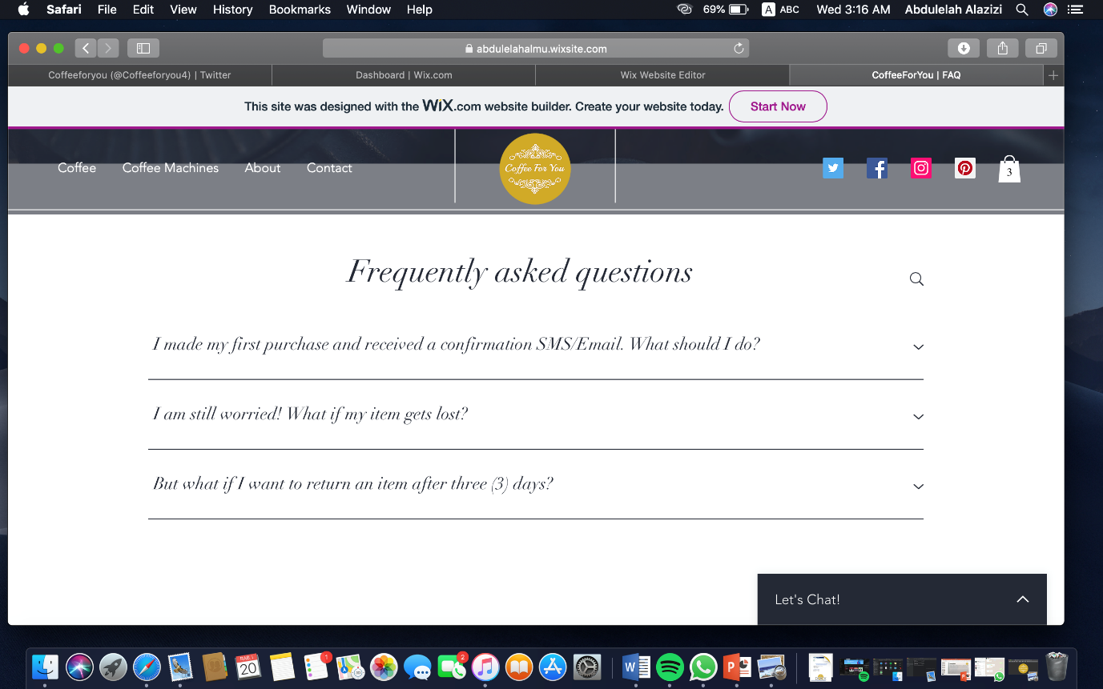

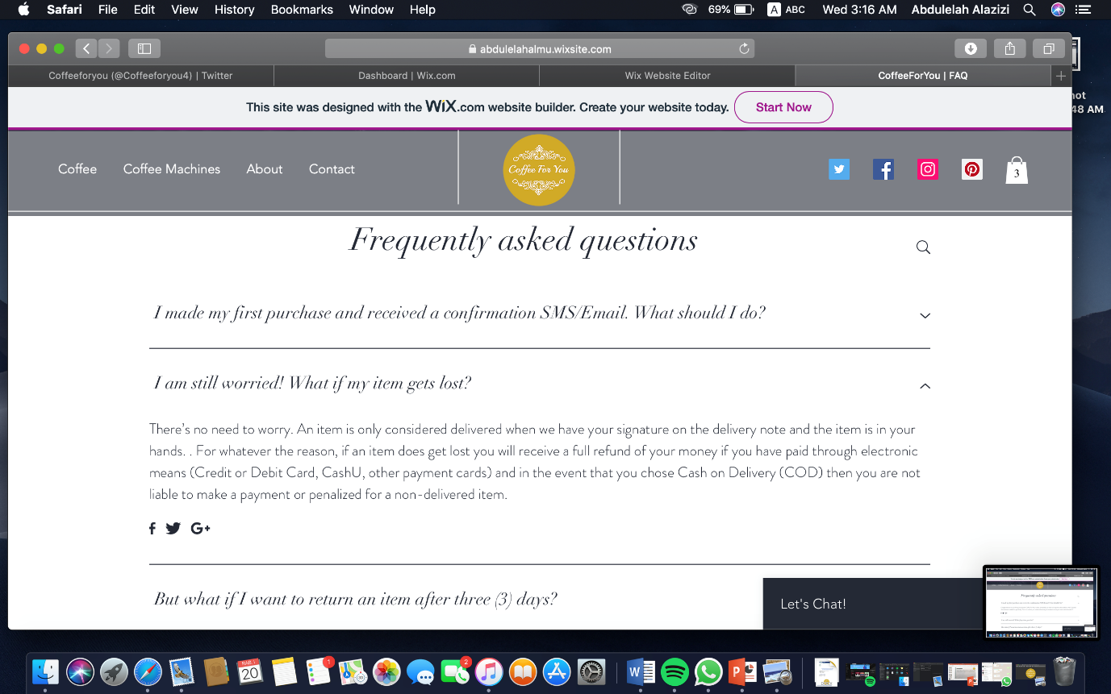

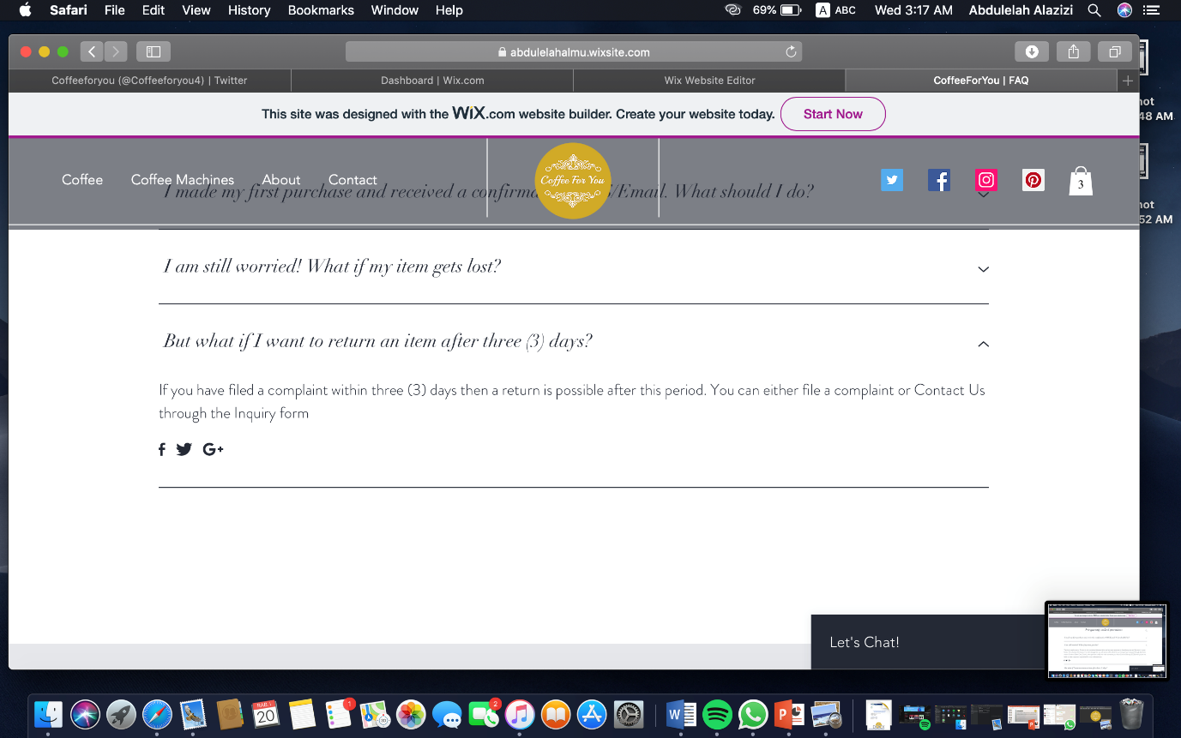

Shipping & Returns Page:

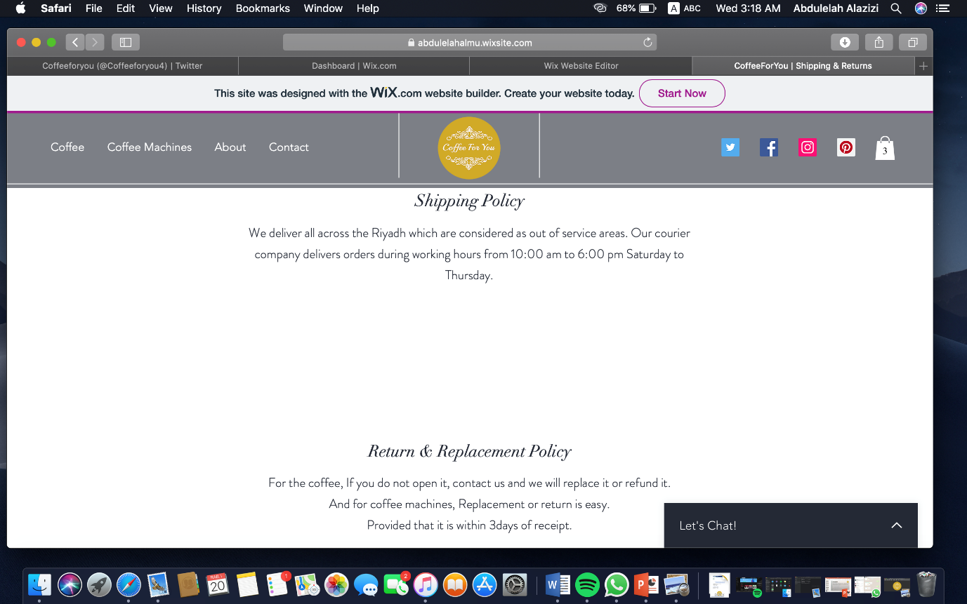

Cart:

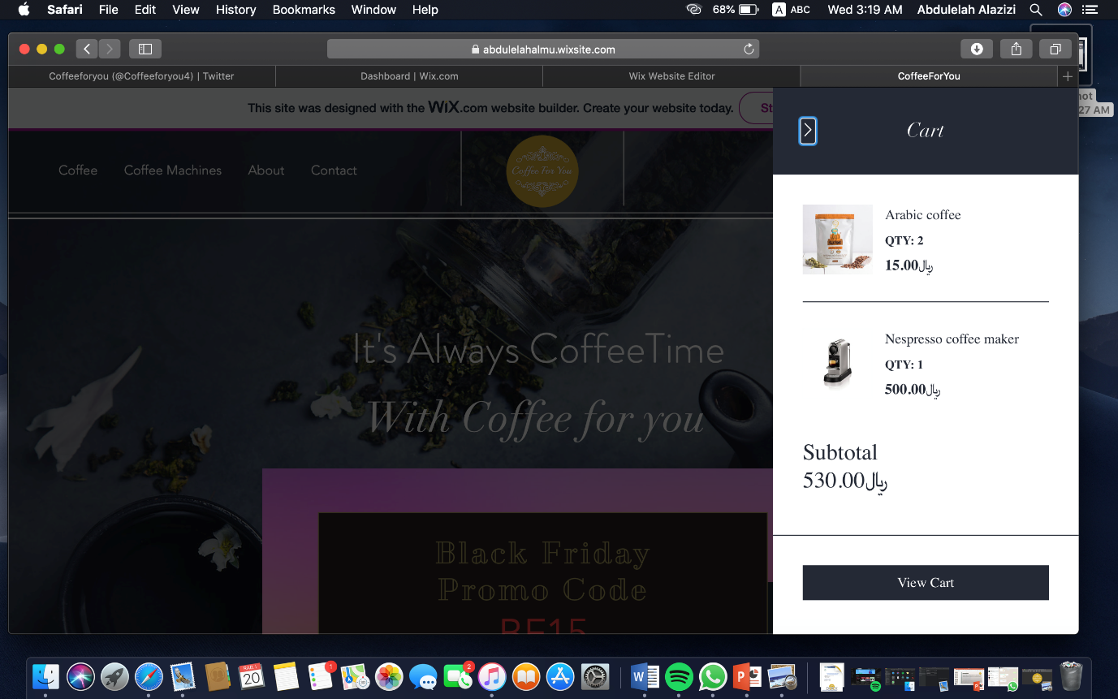

Check out page:

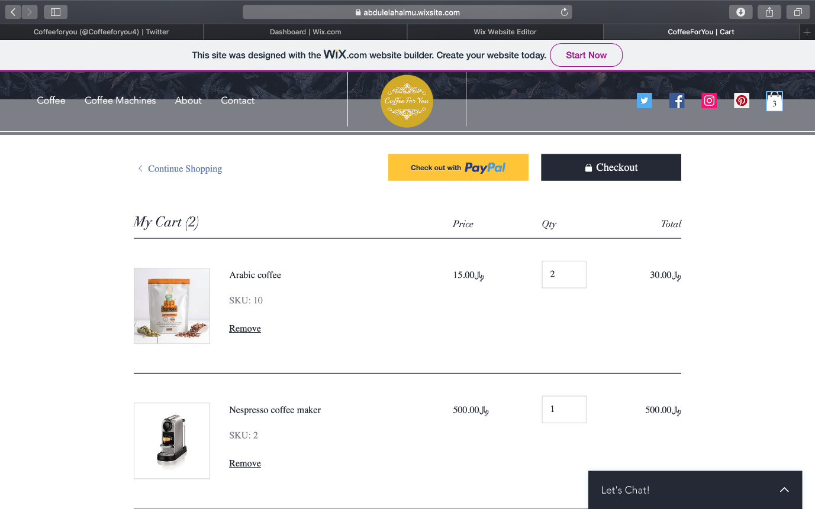

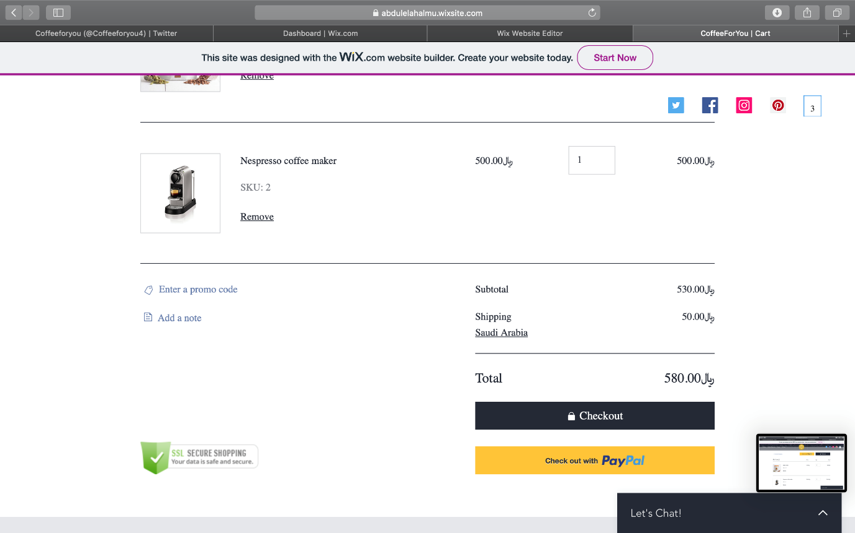

Using BF15 code for Black Friday discount:

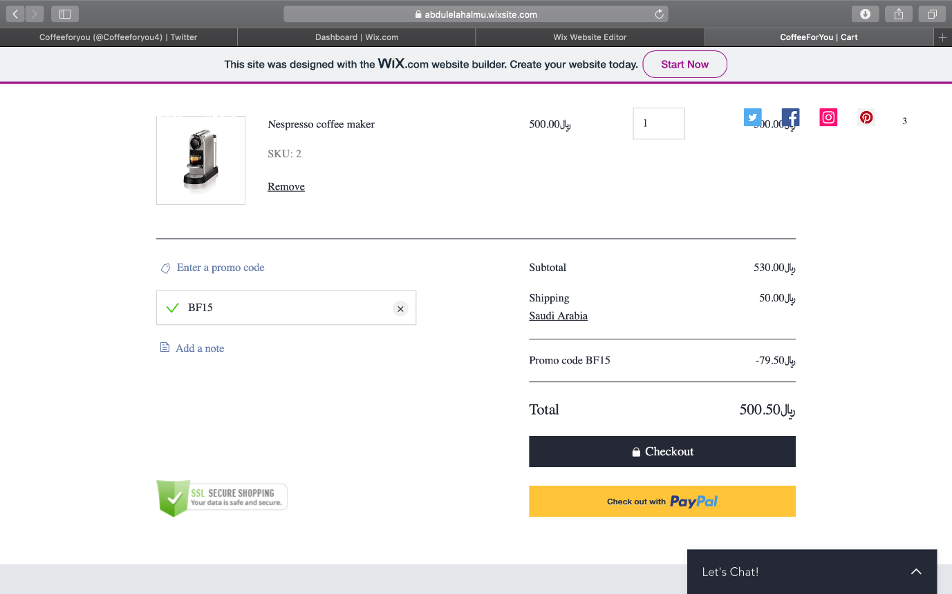

Using FREE code for free delivery how just see our site from twitter:

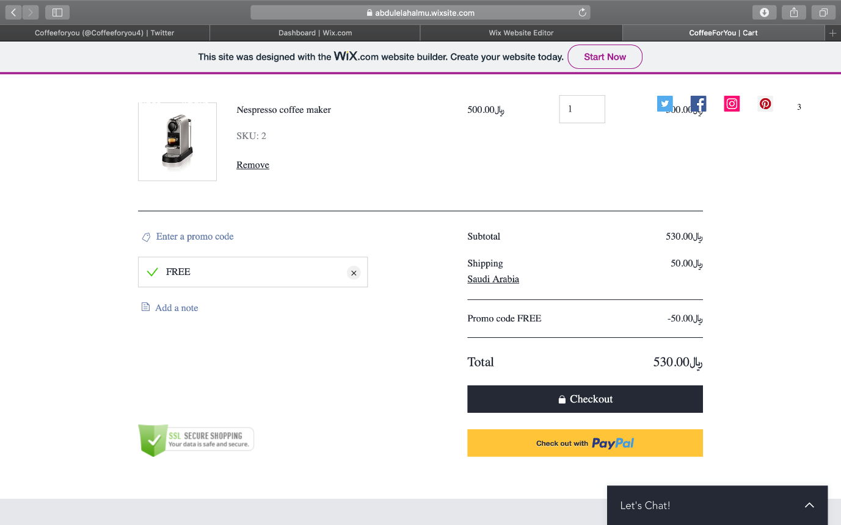

Twitter page:

